

Date: <To2>

TO WHOM IT MAY CONCERN

It is certified that Mr. <Name> S/O <Fname> CNIC No. <CNIC> in our organization as <Designation> in South Punjab Hospital from <From2> to <To2>.

During Service we found him hard working and professionally sound. We wish him great success in his future.

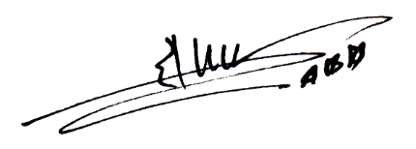Managing Officer

**South Punjab Hospital Suraj Miani Road Chungi No.1**